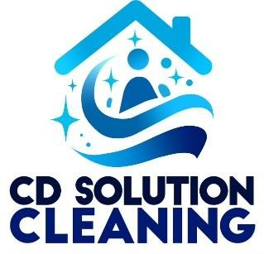

Office Cleaning Checklist:

Reception Area
- Clean and disinfect reception desk
- Clean and disinfect phone and other equipment
- Wipe and sanitize door handles and light switches
- Dust all furniture and fixtures - Vacuum or mop floors

Meeting Rooms / Conference Rooms
- Clean and disinfect tables and chairs
- Dust all surfaces, including electronics
- Vacuum or mop floors
- Empty trash bins
- Wipe and sanitize door handles and light switches

Workstations and Cubicles
- Dust desks, chairs, and shelves
- Clean computer monitors and keyboards
- Empty trash bins and replace liners - Vacuum or clean floors
- Wipe and sanitize shared surfaces

Restrooms
- Clean and disinfect toilets, sinks, and countertops
- Refill soap dispensers and hand towels
- Restock toilet paper and other supplies
- Sweep and mop floors
- Empty and sanitize trash bins

Kitchen / Break Room
- Clean and sanitize sink and countertops
- Wipe down appliances and coffee machines
- Empty and clean refrigerator (if applicable)
- Sweep and mop floors
- Empty and sanitize trash bins

General Areas and Hallways
- Dust all ledges, handrails, and fixtures
- Vacuum carpets and mop floors
. - Wipe and sanitize door handles and light switches
- Remove cobwebs and spot clean walls
- Empty and sanitize trash bins

Others
- Check and restock cleaning and restroom supplies
- Clean and disinfect glass doors and windows
- dusting of vents and fixtures
- Spot clean marks on walls and doors - Inspect and report any maintenance issues.

