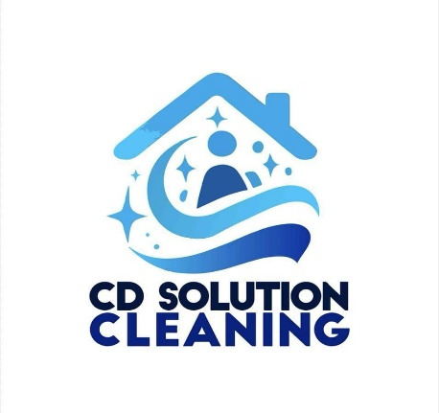
Airbnb Cleaning Checklist:

Living Room:

- Dust and clean all surfaces
- Vacuum and mop floors
- Clean the window and mirrors
- Wipe down furniture
- Wash and removable pillows cover and throws
- Wipe down light switches and door handles
- Empty and clean trash bins
- Dust and clean ceiling fans and light fixtures and windows blinds

Kitchen:

- Clean and sanitize all countertops and surfaces
- Clean appliances (toaster, coffee maker)
- Clean inside and outside of the microwave
- Clean inside oven and stove top
- Wipe down cabinets
- Empty, clean and sanitize the refrigerator
- Sweep and mop the floor, Run dishwasher on empty
- Empty and clean trash bins
- Wash all the dirty dishes and put inside cabinets in a nice orderly fashion
- Leave a roll of trash bags, paper towel, dishwasher detergent in the cabinet
- Refill hand soap, Dish soap, sponges

Bathrooms:

- Clean and disinfect sink, shower, bathtub, and toilet
- Clean mirrors
- Sweep and mop the floor Empty and clean trash bins
- Wash and replace towels
- Wash and replace bathmats
- Leave a roll of small trash bags under the sink in a cabinet
- Wash shower curtain
- Deep clean grout in shower/ bathtub and floor
- Clean cabinets and storage inside and remove and clutter
- Refill Shower Gel, Shampoo, Conditioner and Hand Soap from the storage

Bedrooms:

- Wash and replace all lines
- Dust and clean all surfaces and decorations
- Vacuum and mop the floor
- Clean windows and mirror
- Sanitize light switches and door handles
- Empty and clean trash bins
- Don't forget to clean under the bed
- Dust and clean light fixtures and ceiling fans

Laundry Room:

- Leave a container of laundry detergent for guests to use
- Wipe down the washer and dryer, especially the detergent intake section
- Remove lint from the dryer

Backyard:

- Check the grill BBQ and use brush if left dirty to clean the crates
- Organize chairs and lounge chairs if left disorderly



CD Solution Cleaning ■ Tel: 561-475-6608 ■ www.cd-solutioncleaning.com

